TABLE OF CONTENTS
EXCECUTIVE SUMMARY 2
I. Introduction 4
II. Literature Review 6
2.1. Aspect-Based Sentiment Analysis (ABSA) Application in the Restaurant Industry 6
2.2. Aspect Representation in Prior ABSA Studies 7
III. Proposed DSS Model 9
3.1. Objectives of the DSS 9
3.2. DSS Architecture 11
3.2.1. System Architecture Overview 11
3.2.2. DSS Workflow Description 12
IV. Proposed Method 13
4.1. Data Collection 13
4.2. Text Processing 16
4.3. Aspect Identification 17
4.4. Sentiment Analysis and Aggregation 24
4.5. Exploratory Data Analysis (EDA) 26
4.5.1. Customer Rating Overview 27
4.5.2. Aspect-level Rating Analysis 28
4.6. Proposed Modeling Approach 30
V. Implementation and Evaluation 35
5.1. System Implementation 35
5.2. Experimental Setup 36
5.3. Evaluation Results 37
5.4. Application 41
5.5. Limitations and Future Work 44
5.5.1. Limitations 44
5.5.2. Future Work 45
VI. Conclusion 46
REFERENCES 47

TABLE OF FIGURES
Figure 1. Overall architecture of the proposed ABSA system for KFC Google Maps reviews 10
Figure 2. Overall Sentiment Label Distribution 25
Figure 3. Sentiment Label Distribution by Aspect (Stacked Bar Chart) 26
Figure 4. Customer Rating Overview and Aspect Distribution Across KFC Branches in Hanoi 27
Figure 5. Average Aspect Ratings Across All KFC Branches 28
Figure 6. Aspect-level Rating Comparison Across KFC Branches 29
Figure 7. Accuracy Comparison of 3 Models Across Aspects 41
Figure 8. Interactive Branch Map and Review Dashboard for 15 KFC Stores in Hanoi 43
TABLE OF TABLES
Table 1. Summary of Related Studies on Aspect-Based Sentiment Analysis in the Restaurant and Hospitality Domain 8
Table 2. Data Distribution of 15 KFC Branches in Hanoi 14
Table 3. LDA Topic–Keyword Distributions for KFC Review Corpus 20
Table 4. Mapping of Aspects to LDA Topics and Representative Keywords 21
Table 5. Keyword List for the Two Newly Added Aspects 23
Table 6. Accuracy Comparison of 3 Models Across Aspects 38

EXCECUTIVE SUMMARY
This study extends traditional sentiment analysis by moving beyond overall document-level evaluation to focus on specific aspects that shape customer experience. This aspect-based approach enables a more detailed and actionable understanding of customer feedback, revealing which service components drive satisfaction or dissatisfaction. To achieve this objective, Latent Dirichlet Allocation (LDA) is applied to uncover latent topics from a large-scale corpus of customer reviews. These topics are subsequently interpreted and refined based on service management theory and the operational context of the fast-food industry, resulting in a structured aspect framework that includes food quality, service efficiency, restaurant space, pricing, and promotional policies.
To ensure the reliability of the training data, aspect-level sentiments are manually annotated using a multi-level labeling scheme. This annotation process plays a critical role in capturing subtle linguistic nuances, mixed opinions, and ambiguous expressions that are often difficult to handle accurately using fully automated sentiment analysis methods.
During the modeling phase, customer reviews are represented using TF-IDF features combined with n-gram techniques in order to capture both term importance and local contextual patterns. Three widely used machine learning algorithms are evaluated on independent aspect-level sentiment classification tasks, including Support Vector Machine, Logistic Regression, and Naive Bayes. The experimental results indicate that discriminative linear models, particularly Support Vector Machine and Logistic Regression, achieve superior accuracy and stability, especially for aspects with clear sentiment signals such as pricing and promotions. In contrast, overall customer experience remains more challenging to classify due to its multidimensional and dispersed nature.
From an application perspective, this study develops an interactive decision support dashboard that enables near real-time monitoring of customer sentiment trends and detailed analysis by branch and service aspect. By integrating quantitative sentiment indicators with representative keywords and illustrative customer reviews, the system allows managers to quickly identify critical customer pain points and operational weaknesses. These insights support data-driven improvements in service quality, operational efficiency, and marketing strategy, ultimately contributing to an enhanced customer experience.

I. Introduction
KFC (Kentucky Fried Chicken) is a global fast-food brand owned by Yum Brands (USA), specializing in fried chicken, grilled chicken, and chicken-based meals. The brand’s signature product is its Original Recipe fried chicken, developed by Colonel Harland Sanders using a blend of 11 herbs and spices. As of today, KFC operates more than 20,000 restaurants across 109 countries and territories worldwide [1].
In the digital era, customer reviews and online feedback have become influential factors shaping a company’s reputation and business performance. For fast-food chains such as KFC, a large volume of customer comments shared daily on social media platforms, food delivery applications, and online review websites reflects customer satisfaction and perceptions of service quality. These user-generated reviews serve as a valuable data source for understanding customer behavior and evaluating brand perception, thereby supporting service improvement and strategic decision-making.
However, analyzing such large-scale textual feedback presents significant challenges. Customer reviews are typically written in natural language and often contain mixed opinions. For example, a customer may express satisfaction with food quality while simultaneously criticizing slow service or poor staff attitude. Traditional sentiment analysis approaches, which classify opinions into broad categories such as positive or negative, are limited in capturing these fine-grained distinctions across different aspects of the same customer experience.
To address this limitation, this project applies Aspect-Based Sentiment Analysis (ABSA) to analyze customer feedback related to KFC. ABSA is a text analysis technique that identifies specific aspects mentioned in a review and determines the sentiment polarity associated with each aspect. By linking opinions to particular aspects of a product or service, ABSA enables a more detailed and accurate interpretation of customer sentiment [2]. Previous research has demonstrated the effectiveness of this approach. For instance, Pontiki et al. (2016), through the SemEval competition which is a leading benchmark in natural language processing showed that ABSA provides more fine-grained and informative sentiment analysis compared to traditional methods [3]. Furthermore, in the study “Aspect-Based Sentiment Analysis of Arabic Restaurants Customers’ Reviews Using a Hybrid Approach,” the authors applied ABSA to restaurant reviews and demonstrated its ability to identify customer “pain points” and “delight points” across different service aspects [4].
The effectiveness of ABSA has also been validated in various service-related domains. In the hospitality sector, Pinheiro Silva and Silva Chinelatto, in their study “Aspect-Based Sentiment Analysis on Online Customer Reviews: A Case Study in the Hotel Industry,” analyzed thousands of online reviews and found that specific aspects such as smart rooms, automated lighting, and service robots received highly positive evaluations, contributing significantly to overall customer satisfaction [5]. Similarly, the study “Aspect-Based Sentiment Analysis of Customer Reviews in E-Commerce”demonstrated that ABSA can accurately extract and evaluate sentiment related to specific aspects such as product features, delivery speed, and customer service, thereby providing detailed insights into strengths and weaknesses from the customer perspective [6].
In practice, customer reviews of KFC branches in Hanoi frequently contain both positive feedback and critical comments, highlighting the need for a fine-grained analytical approach capable of distinguishing sentiment across different service aspects. Accordingly, this project aims to develop an aspect-based sentiment analysis model that automatically extracts key aspects of KFC services including food quality, staff behavior, cleanliness, pricing, and service speed, and assigns sentiment polarity to each identified aspect. The proposed system will generate analytical reports and visualizations summarizing sentiment trends across different KFC branches in Hanoi. These outputs will help identify frequently discussed aspects, evaluate sentiment distributions, and highlight specific strengths and issues at individual locations. Ultimately, the project seeks to provide data-driven insights that support managerial decision-making, service quality improvement, and effective brand management.

II. Literature Review

2.1. Aspect-Based Sentiment Analysis (ABSA) Application in the Restaurant Industry
Sentiment Analysis is commonly used to study customer opinions from online reviews and social media. Traditional sentiment analysis usually assigns one sentiment label, such as positive or negative, to an entire review. However, customer reviews in the restaurant and fast food industry often contain mixed opinions. For example, a customer may like the food but complain about slow service or high prices. Because of this limitation, Aspect Based Sentiment Analysis has been widely adopted.
Aspect Based Sentiment Analysis allows researchers to identify specific aspects mentioned in a review and determine the sentiment toward each aspect. This approach is especially suitable for restaurants and fast food services, where customer experience is influenced by multiple factors such as food quality, service quality, price, and dining environment.
Many studies have applied ABSA to restaurant reviews and shown its effectiveness. Carrasco and Dias [7] used advanced natural language processing models to analyze restaurant reviews and demonstrated that aspect level sentiment analysis can help managers better understand customer feedback. Jeong et al. [11] found that emotions expressed toward specific aspects play an important role in how useful a review is perceived by other customers.
Different methods have been used to implement ABSA in the restaurant domain. Amalia and Winarko [8] applied deep learning models to analyze restaurant reviews in Indonesian. Rahman et al. [12] focused on multilingual restaurant reviews and highlighted challenges related to language differences. George and Srividhya [10] used topic modeling to identify implicit aspects, showing that aspects do not always appear explicitly in customer reviews.
Overall, previous studies confirm that ABSA provides more detailed and meaningful insights than overall sentiment analysis. By analyzing sentiment at the aspect level, researchers and practitioners can better understand what customers like or dislike in restaurant and fast food services.

2.2. Aspect Representation in Prior ABSA Studies
In previous ABSA research, the term “aspect” is not always used consistently. Some studies refer to aspects as service attributes, value dimensions, or experience dimensions. Despite different terms, these concepts all describe meaningful components of customer experience that help organize and interpret customer opinions.
Many studies define aspects based on commonly accepted service dimensions rather than purely algorithmic outputs. For example, Li et al. [9] showed that sentiment related to food quality and location is more useful than overall sentiment when predicting restaurant survival. Nguyen et al. [14] studied customer satisfaction at KFC Vietnam and identified food quality, service quality, and price as important factors affecting customer perceptions.
Other studies use topic modeling techniques, such as LDA, to discover common themes in review text. These themes are then interpreted using domain knowledge and findings from previous research. George and Srividhya [10] demonstrated that topics extracted from restaurant reviews can be meaningfully interpreted as service related dimensions when guided by existing literature. Jeong et al. [11] also emphasized that analyzing sentiment by aspect provides deeper insights into customer behavior than using overall sentiment alone.
Across different studies and service contexts, including restaurants and hotels, customer opinions are commonly structured around a small number of recurring dimensions. These dimensions typically relate to product quality, service performance, price, physical environment, and overall experience. Although the specific terminology varies, the underlying idea of organizing customer feedback into interpretable dimensions remains consistent.
Table 1 summarizes several representative studies and shows how aspects or dimensions are defined and used in previous ABSA research related to restaurants and hospitality services.
Table 1. Summary of Related Studies on Aspect-Based Sentiment Analysis in the Restaurant and Hospitality Domain
Study | Data / Domain | Method | Aspects / Dimensions
Carrasco & Dias (2024) [7] | Restaurant reviews | LLMs (BART, ChatGPT) | Food quality, service quality, price, atmosphere
Amalia & Winarko (2021) [8] | Indonesian restaurant reviews | CNN + contextual embeddings | Food, service, price, cleanliness
Rahman et al. (2025) [12] | Multilingual restaurant reviews | Aspect-focused learning | Food, service, environment, price
Jeong et al. (2024) [11] | Online restaurant reviews | BERT-based ABSA | Food attributes, service attributes, ambiance
George & Srividhya (2023) [10] | Restaurant reviews | LDA + ensemble classifiers | Implicit aspects including waiting time, service speed
Li et al. (2023) [9] | Restaurant survival analysis | ABSA + predictive modeling | Food quality, location, price perception
Andhika et al. (2023) [13] | KFC Indonesia (Twitter) | Naïve Bayes, AdaBoost | Product quality, service speed, price
Nguyen et al. (2019) [14] | KFC Vietnam | Survey-based analysis | Food quality, service quality, perceived value
As shown in Table 1, previous studies consistently analyze customer feedback using a set of interpretable service related dimensions. While different methods and terms are used, these studies share a common goal of structuring unstructured customer reviews into meaningful components. This literature provides a clear theoretical background for applying aspect based sentiment analysis in the restaurant and fast food context.

III. Proposed DSS Model

3.1. Objectives of the DSS
The primary objective of the proposed Decision Support System (DSS) is to assist managers and decision-makers in the fast-food industry in understanding, monitoring, and improving customer experience through data-driven insights derived from customer reviews.
Specifically, the DSS is designed to transform large volumes of unstructured textual feedback into structured, interpretable, and actionable information by applying Aspect-Based Sentiment Analysis (ABSA). Instead of relying on overall sentiment scores, the system enables fine-grained analysis of customer opinions across multiple service dimensions, providing deeper insight into the drivers of customer satisfaction and dissatisfaction.
The key objectives of the proposed DSS are as follows:
- To provide aspect-level sentiment insights that capture customer perceptions across critical service dimensions such as food quality, pricing, promotions, service quality, restaurant space, service process, and overall customer experience.
- To support branch-level and system-wide performance evaluation by identifying strengths, weaknesses, and sentiment patterns across different KFC locations.
- To enable early detection of operational issues and emerging trends, allowing managers to respond proactively to service problems such as long waiting times, declining service quality, or negative reactions to pricing and promotions.
- To enhance strategic and operational decision-making in areas including service improvement, staff training, operational optimization, and marketing strategy adjustment.
- To provide an interpretable and user-friendly analytical interface, ensuring that non-technical users can easily understand analytical results and integrate insights into daily management practices.
Overall, the proposed DSS serves as a practical decision-support tool that bridges the gap between advanced sentiment analysis techniques and real-world business management needs. By converting customer feedback into structured knowledge, the system supports more informed, timely, and effective decision-making in the fast-food service context.

3.2. DSS Architecture
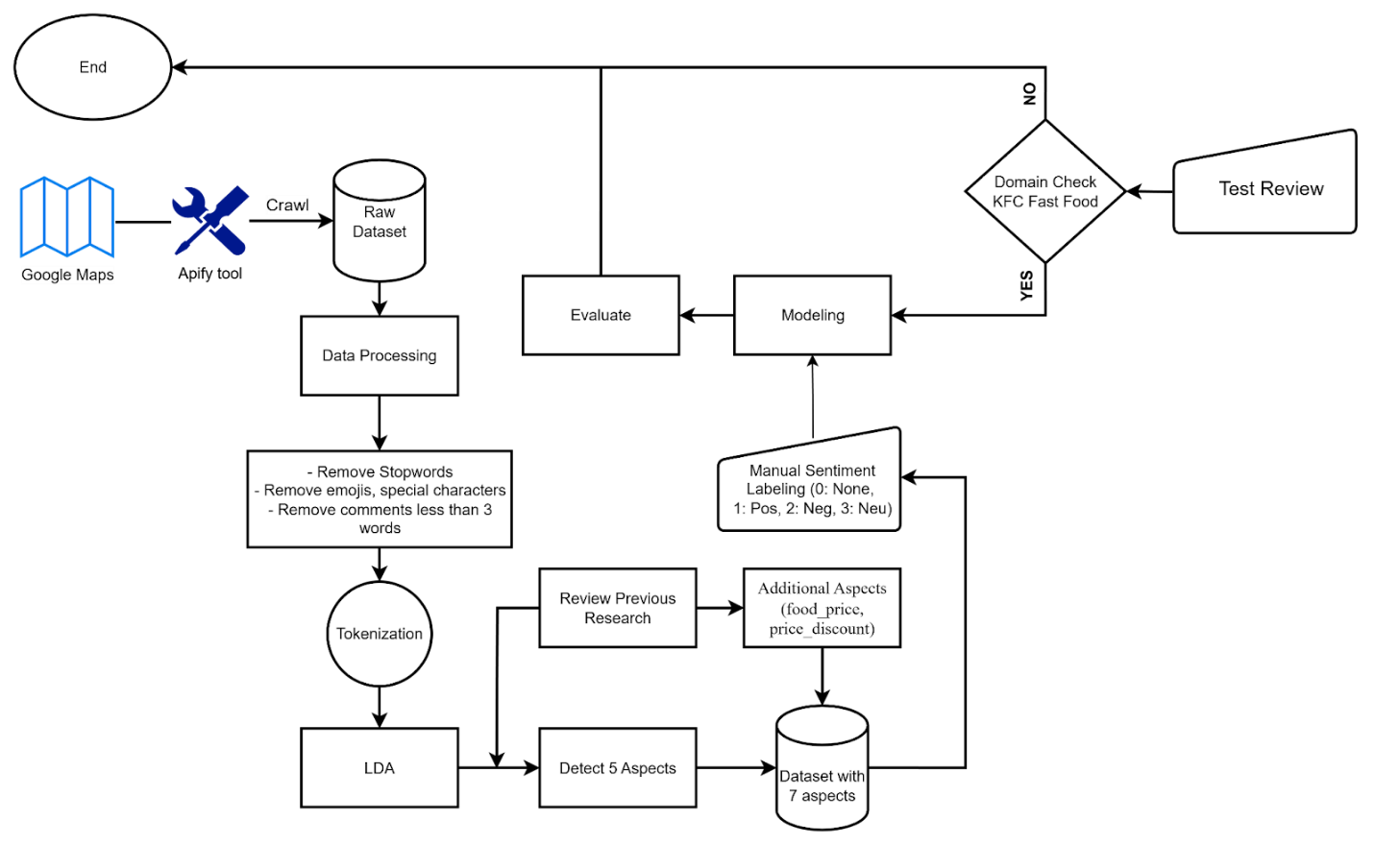
Figure 1. Overall architecture of the proposed ABSA system for KFC Google Maps reviews

3.2.1. System Architecture Overview
As illustrated in Figure 1, the proposed Decision Support System (DSS) architecture is designed as an integrated, modular system that supports aspect-based sentiment analysis and managerial decision-making. The architecture consists of four main components that collectively transform raw customer reviews into actionable insights.
The first component is the Data Collection module, which is responsible for acquiring raw customer reviews from online platforms. In this study, reviews are collected from Google Maps, together with branch-related metadata, forming the initial unstructured dataset.
The second component is the Data Processing and Aspect Extraction module. This component handles text preprocessing and feature preparation, as well as aspect identification based on LDA topic modeling and theory-driven mapping. Its role is to convert unstructured textual data into structured, aspect-level representations suitable for sentiment analysis.
The third component is the Modeling and Evaluation module, where aspect-based sentiment classification models are trained and evaluated. This module applies machine learning algorithms to predict sentiment polarity for each identified aspect and assesses model performance using appropriate evaluation metrics.
The final component is the Decision Support Interface, which presents analytical results through an interactive dashboard. This component enables users to explore sentiment trends, compare performance across branches and aspects, and interpret results in a form that directly supports managerial decision-making.
Together, these components form a cohesive DSS architecture that ensures scalability, interpretability, and practical applicability in the fast-food service context.

3.2.2. DSS Workflow Description
The workflow illustrated in Figure 1 describes the complete data processing and modeling pipeline of the proposed ABSA-based decision support system for KFC customer reviews.
The process begins with data collection from Google Maps, a widely used review platform in the food and beverage domain. Customer reviews are collected using an automated crawling tool, resulting in an initial raw dataset that contains textual reviews together with branch-related metadata.
The raw dataset is subsequently passed to the data processing stage, where the textual data undergo a standardized preprocessing pipeline. This stage includes removing stopwords, eliminating emojis and special or non-alphanumeric characters, filtering out reviews with fewer than three words due to insufficient contextual information, and performing tokenization to segment the text into lexical units suitable for modeling.
After preprocessing, Latent Dirichlet Allocation is applied to the review corpus in order to identify latent topics. The extracted topics and their representative keywords are then interpreted in conjunction with findings from prior research and the operational context of the fast-food industry. This process leads to the identification of five core aspects that capture key dimensions of customer experience. In parallel, further inspection of the empirical data and relevant literature supports the inclusion of two additional price-related aspects, namely food_price and price_discount. As a result, the final dataset is annotated with seven distinct aspects.
Following aspect identification, manual sentiment labeling is conducted at the aspect level. Each review and aspect pair is assigned one of four sentiment labels, including 0 for None, indicating that the aspect is not mentioned, 1 for Positive, 2 for Negative, and 3 for Neutral. Manual annotation is employed to ensure the reliability and quality of the ground truth, particularly for reviews that contain ambiguous expressions or mixed sentiments.
The labeled dataset is then used in the modeling component, where aspect-based sentiment classification models are trained. Model performance is subsequently evaluated using appropriate performance metrics. Finally, the trained models are validated through a domain-specific check tailored to the KFC fast-food context and tested on unseen review samples to ensure practical applicability. Upon completion of these steps, the decision support system generates structured analytical outputs to support managerial decision-making.

IV. Proposed Method

4.1. Data Collection
This study employs Apify, an automation and web scraping platform, to collect customer reviews from Google Maps using the Google Maps Reviews Scraper tool. Google Maps is selected as the data source because it is one of the most widely used review platforms in Vietnam and provides reliable insights into real customer experiences in the food and beverage industry. Reviews published on Google Maps are voluntarily shared by users after service consumption, thereby ensuring the naturalness and objectivity of the feedback.
The data collection process is conducted through several steps. First, the research team manually checks the number of existing reviews for each KFC branch on Google Maps in order to estimate the size of the dataset to be collected. On the Apify platform, the scraper allows users to specify the number of reviews to retrieve. In this study, this parameter is configured to match the number of reviews currently displayed on Google Maps at the time of data collection, ensuring that all available reviews are fully retrieved.
After configuring the required parameters, the data collection process is initiated through Apify. The scraper automatically sends requests to Google Maps and collects all reviews associated with the provided place URLs until the specified review limit is reached or no additional reviews are available.
The resulting dataset consists of 11,435 records and 12 attributes, containing essential information for subsequent analysis. Specifically, the collected fields include store_name, address, user_name, review_time, review_text, rating, source, and language, together with other auxiliary metadata provided by the platform. These attributes enable both textual analysis and branch-level comparison, supporting sentiment analysis as well as spatial and temporal exploration of customer feedback.
The reviews are initially collected in Vietnamese in order to preserve the original emotional tone and local context expressed by customers. Subsequently, the data are translated into English to facilitate preprocessing, textual analysis, and model development in later stages of the research. Although machine translation may introduce a certain degree of semantic noise, its impact is expected to be limited in this study because sentiment classification relies on TF-IDF representations rather than deep semantic embedding models. TF-IDF primarily captures surface-level lexical features and term frequency patterns, making the approach relatively robust to minor grammatical inconsistencies or semantic shifts introduced during translation, provided that key sentiment-bearing terms are preserved.
Table 2. Data Distribution of 15 KFC Branches in Hanoi
store_name | count | percent (%)
KFC The Manorp | 3406 | 29.78
KFC Thanh Xuân Bắc | 1324 | 11.58
KFC Đống Đa | 1163 | 10.17
KFC Vincom | 917 | 8.02
KFC TTTM Hồ Gươm Plaza | 914 | 7.99
KFC Vạn Khê | 867 | 7.58
KFC Láng Hạ | 805 | 7.04
KFC Trần Thủ Hộ | 781 | 6.83
KFC Trần Duy Hưng | 528 | 4.62
KFC Lê Thanh Nghị | 329 | 2.88
KFC Royal City | 163 | 1.43
KFC Phạm Ngọc Thạch | 145 | 1.27
KFC Bạch Mai | 43 | 0.38
KFC Quang Trung | 36 | 0.31
KFC TTTM Mê Linh | 15 | 0.13
TOTAL | 11436 | 100.00
Table 2 summarizes the number of observations (count) and the corresponding percentage (percent) for each KFC branch in the overall dataset. Aggregating the data at the branch level allows the study to clearly describe the structure and degree of concentration of the dataset, as well as to assess the representativeness of each store within the research sample.
These results also provide an important basis for subsequent analyses, such as comparing sentiment patterns across locations, identifying branches with a notably high volume of customer feedback, and considering the potential impact of uneven data distribution on the training and evaluation of the ABSA model.

4.2. Text Processing
Before applying Aspect-Based Sentiment Analysis, the customer reviews were processed through several text processing steps. The purpose of this process is to clean the raw text, remove noise, and convert the reviews into a format that is easier to analyze.
The text processing pipeline consists of five main steps, described as follows.
Preprocessing
The preprocessing step is used to check the basic quality of the text data before cleaning and analysis. In this step, the text data are examined to make sure that there are no missing values and that all entries are valid text.
The results show that the dataset does not contain missing text values and that all reviews are valid. Therefore, no data were removed or corrected at this stage. This step ensures that the text data are ready for the next processing steps.
Remove stopword
The purpose of this step is to remove common words that appear very frequently in text but do not provide useful information for analysis. These words, called stopwords, include examples such as “the”, “is”, “and”, and “to”. Although they are important for grammar, they do not help identify customer opinions or service aspects.
In this step, stopwords are removed from the text after converting all words to lowercase. As a result, the remaining text mainly contains meaningful words related to customer experiences, such as food, service, price, and taste. This makes the text clearer and easier to analyze in later steps.
Remove emojis , special and unwanted characters
Customer reviews collected online often contain emojis, symbols, and special characters. These elements do not add useful information for understanding the content of the review and may create noise in the data.
In this step, emojis, special characters, and unnecessary symbols are removed from the text. After this cleaning process, the text becomes more consistent and easier to read. The result is a cleaner version of the reviews that focuses only on meaningful words.
Filter comment less than 3 word
Some reviews are very short, such as “Good” or “Very nice”. Although these comments express an opinion, they usually do not provide enough information to identify specific aspects like food quality or service.
In this step, comments that contain fewer than three words are removed. The result is a dataset that contains reviews with more information and clearer context, which helps improve the quality of aspect-based analysis.
Tokenization
The purpose of tokenization is to split each review into individual words. This step converts the text from a sentence format into a list of words that can be easily processed by analytical models.
After tokenization, each review is represented as a list of words, for example: “food delicious tasty” becomes [food, delicious, tasty]. This structured format allows the text to be used effectively in later steps such as aspect extraction and sentiment analysis.
After completing all text processing steps, the raw customer reviews are transformed into clean, consistent, and structured text data. The processed text contains meaningful words, fewer irrelevant elements, and clearer context. This final output is well-prepared for subsequent analysis, including aspect extraction and sentiment analysis.

4.3. Aspect Identification
In this study, the set of aspects for Aspect-Based Sentiment Analysis (ABSA) is identified based on two primary sources: (1) the results obtained from Latent Dirichlet Allocation (LDA) topic modeling, and (2) a synthesis of findings from relevant related work. By integrating data-driven topic discovery with prior academic studies, five core aspects are established for the analysis, including food_quality, service_quality, service_order, restaurant_space, and customer_experience.
From a methodological perspective, Latent Dirichlet Allocation (LDA) is an unsupervised probabilistic topic modeling approach designed to uncover latent thematic structures within large collections of textual data. LDA assumes that each review is composed of a mixture of multiple topics with different proportions, while each topic is characterized by a weighted distribution over words. As a result, the most representative keywords of each topic can be interpreted and mapped to specific dimensions of customer experience, enabling the identification of meaningful service- and product-related aspects.
To evaluate the quality of the topics extracted by the LDA model and to determine an appropriate number of topics, this study employs the Coherence Score (CS) metric. Coherence Score measures the semantic consistency among the top keywords representing a topic, based on the assumption that words belonging to the same topic tend to co-occur within similar textual contexts [26]. From a mathematical perspective, the Coherence Score is computed using the set of top-N words with the highest probabilities for each topic and quantifies the degree of word co-occurrence across the entire corpus. A commonly used formulation of the Coherence Score can be expressed as follows:
$$CS\left(W\right)= \sum_{i=1}^{N}{ \sum_{j=i+1}^{N}{ \log{\frac{P\left(w_{i},w_{j}\right)+ε}{P\left(w_{i}\right)}}}}$$
where:
- $w_{i}$​ and $w_{j}$​ are two words belonging to the keyword set of a topic,
- $P\left(w_{i},w_{j}\right)$ denotes the probability that the two words co-occur within the same document,
- $P\left(w_{i}\right)$ represents the marginal probability of occurrence of word $w_{i}$​,
- $ε$ is a smoothing constant introduced to avoid zero probability values [27].
The LDA configuration that achieves the highest Coherence Score is selected, as higher coherence indicates that the extracted topics exhibit stronger semantic relatedness, improved interpretability, and reduced overlap compared to alternative configurations. This criterion is particularly important for Aspect-Based Sentiment Analysis (ABSA), where topics must clearly reflect distinct dimensions of customer experience in order to support the identification and validation of the aspect system adopted in this study [25], [27].
To ensure the quality of the extracted topics, the textual data are preprocessed prior to LDA training using a standardized pipeline. The process includes removing stopwords to reduce linguistic noise, eliminating emojis and special or non alphanumeric characters to avoid vocabulary fragmentation, and filtering out very short reviews with fewer than three words due to insufficient contextual information. Tokenization is then applied to segment the text into individual lexical units, which are used to construct the document term matrix for the LDA model. This preprocessing procedure allows LDA to focus on informative keywords, improving topic coherence and enabling more accurate alignment with the predefined aspect framework. The resulting keyword distributions for each topic are presented in Table 3.
After training the LDA model, each topic is represented as a probability distribution over the entire vocabulary, where each word is associated with a weight indicating its degree of representativeness for the corresponding topic. These weights correspond to the conditional probabilities $P\left(word | topic\right)$, which are estimated during probabilistic inference under the Dirichlet distribution assumptions of the LDA framework [28].
From a mathematical perspective, the word–topic probability in the LDA model is computed as:
$$P\left(w | z\right)=\frac{n_{z,w}+β}{\sum_{w'}{(n_{z,w^{'}}+β)}}$$
where:
- $w$ denotes a word in the vocabulary,
- $z$ represents a topic,
- $n_{z,w}$ is the number of times word $w$ is assigned to topic $z$ during the model inference process,
- $β$ is the Dirichlet hyperparameter used to smooth the word–topic distribution,
- The denominator represents the total number of occurrences of all words assigned to topic $z$.
These probabilities are normalized such that the sum of probabilities over the entire vocabulary for each topic equals one. Consequently, the numerical coefficients associated with individual words within a topic represent their relative contribution to the formation of that topic. Words with the highest weights are therefore regarded as representative keywords, which are used to interpret the semantic content of the corresponding topic.
This probabilistic formulation is applied consistently across all topics in the model, regardless of the specific topic or word, ensuring a uniform and interpretable representation of topic–word distributions throughout the LDA framework [28].
Table 3. LDA Topic–Keyword Distributions for KFC Review Corpus
Topic | Top Keywords (with Weights)
Topic 0 | 0.072*"attitude" + 0.064*"staff" + 0.059*"customers" + 0.052*"bad" + 0.049*"long" + 0.040*"service" + 0.027*"wait" + 0.023*"time" + 0.020*"food" + 0.017*"kfc"
Topic 1 | 0.120*"food" + 0.115*"delicious" + 0.110*"staff" + 0.057*"enthusiastic" + 0.048*"service" + 0.046*"good" + 0.043*"friendly" + 0.030*"restaurant" + 0.030*"clean" + 0.026*"chicken"
Topic 2 | 0.028*"staff" + 0.019*"customer" + 0.017*"order" + 0.016*"time" + 0.015*"ordered" + 0.015*"still" + 0.013*"minutes" + 0.011*"asked" + 0.011*"went" + 0.011*"1"
Topic 3 | 0.127*"chicken" + 0.038*"fried" + 0.035*"kfc" + 0.028*"like" + 0.021*"spicy" + 0.021*"eat" + 0.018*"crispy" + 0.017*"rice" + 0.016*"sauce" + 0.014*"cream"
Topic 4 | 0.055*"kfc" + 0.027*"security" + 0.025*"quite" + 0.021*"space" + 0.020*"parking" + 0.020*"guard" + 0.017*"customers" + 0.017*"many" + 0.014*"bit" + 0.014*"restaurant"
Based on the prominent keyword clusters identified from the LDA results, this study aligns each extracted topic with its corresponding aspect in order to ensure consistency between the empirical evidence and the proposed aspect framework. This alignment process enables a data-driven interpretation of customer experience dimensions and supports the validation of the selected aspects.
To systematically present this labeling strategy and facilitate clear interpretation of the results, Table 4 summarizes the relationships among the aspects, LDA topics, and their representative keywords. This table serves as an explanatory bridge, illustrating the rationale for selecting each aspect and demonstrating how it is inferred from real-world review data. The mapping between the five core aspects and their corresponding LDA topics.
Table 4. Mapping of Aspects to LDA Topics and Representative Keywords
Keyword | lda_topic | Keyword
service_quality | Topic 0 | attitude, staff, customers, bad, service, wait
customer_experience | Topic 1 | food, delicious, staff, enthusiastic, good, friendly, restaurant, clean
service_order | Topic 2 | staff, customer, order, time, ordered, minutes, asked
food_quality | Topic 3 | chicken, fried, spicy, crispy, rice, sauce, cream
restaurant_space | Topic 4 | space, parking, security, guard, restaurant
In parallel with the qualitative evidence derived from the LDA topic modeling results, the selection of the five core aspects is further reinforced by foundational studies in the food and beverage (F&B) and service management literature. The primary objective is to construct an ABSA framework that offers stronger explanatory and predictive capabilities than conventional overall sentiment evaluation approaches ([3], [5]). Accordingly, the identified aspects are not solely data-driven but are also grounded in well-established theoretical frameworks.
Specifically, the service_quality aspect is derived from the SERVQUAL model, which emphasizes key dimensions such as reliability and responsiveness in service delivery [15]. The customer_experience aspect is grounded in experience economy theory, which highlights the importance of the customer’s holistic emotional journey rather than isolated service encounters [16]. The food_quality aspect is evaluated based on attributes such as taste, freshness, and serving temperature, factors that have been consistently shown to be strong predictors of restaurant performance and customer satisfaction ([17], [3]). The restaurant_space aspect is informed by the servicescape framework, which demonstrates the critical role of the physical environment in shaping customer expectations and perceptions of service quality ([18], [4]). Finally, the service_order aspect is explained through queue management principles, emphasizing the importance of operational efficiency and perceived waiting time in fast food service settings [19].
The integration of these five aspects results in a concise yet comprehensive evaluation framework that is well aligned with the objectives of strategic analysis for the KFC brand ([7], [8]) as well as with comparative studies in the food and beverage industry.
Building upon the five core aspects, this study further incorporates two additional aspects, food_price and price_discount, after examining the empirical data and observing a substantial presence of customer reviews related to pricing and promotional programs. These factors are found to directly influence customer satisfaction, revisit intention, and overall business performance in the fast food sector. The inclusion of these aspects is theoretically justified within established service and food and beverage research.
In particular, the food_price aspect is introduced to capture perceived value, which is a direct extension of foundational service quality research [12]. Perceived value conceptualizes value as a trade off between what customers receive, such as food quality as supported by [17], and what they give up in terms of price. The relationship between price and quality has been widely recognized as a critical predictor of restaurant performance and customer evaluations [3]. Meanwhile, the price_discount aspect is examined through the lens of transaction utility, which constitutes an integral component of the broader customer experience ([16], [20]). Promotional offers not only function as marketing instruments but also generate immediate feelings of pleasure and perceived gains, thereby directly influencing customers’ overall service experience.
Furthermore, customer feedback related to discounts, particularly issues concerning transparency or difficulty in applying promotions, is closely associated with principles of operational efficiency and demand management that are also relevant to the service_order aspect [19]. By integrating food_price and price_discount alongside the five core aspects, the proposed framework achieves a more comprehensive representation of customer perceptions, consistent with the goals of strategic analysis for KFC ([7], [8]) and comparative research in the food and beverage domain.
To clearly illustrate the semantic scope of these two newly added aspects and to support consistency in subsequent labeling and interpretation processes, Table 5 presents a list of representative seed keywords for food_price and price_discount. The keyword lists for the newly introduced aspects are summarized in Table 5.
Table 5. Keyword List for the Two Newly Added Aspects
Aspects | Keyword
price_discount | price, pricing, expensive, cheap, …
food_price | discount, promotion, promo, offer, combo, …
The incorporation of these two aspects enhances the ability of the ABSA model to reflect the fast-food consumption context more accurately, in which customer satisfaction and purchase decisions are strongly influenced by perceived value for money, relative pricing compared to food quality, and the appeal of promotional programs or combo offerings.

4.4. Sentiment Analysis and Aggregation
In this study, a four-level sentiment labeling scheme is adopted for the Aspect-Based Sentiment Analysis (ABSA) task, including 0: None (aspect not mentioned), 1: Positive, 2: Negative, and 3: Neutral. The inclusion of the “None” label plays a critical role in distinguishing cases where a review does not refer to a specific aspect, thereby preventing noise during aspect-level model training and evaluation. This design enables the model to focus exclusively on sentiment-bearing instances and improves the robustness of aspect-specific sentiment prediction.
To ensure the accuracy and reliability of the input data, manual sentiment annotation is performed for each review at the aspect level. This approach helps reduce semantic ambiguity, effectively handles vague or polysemous expressions, and enhances the overall quality of the training dataset. As a result, the model is able to learn sentiment signals that are closely aligned with real-world usage contexts, leading to improved predictive performance in subsequent analyses.
The sentiment labeling process in this study is conducted entirely manually to ensure a high level of accuracy and quality control. Five annotators, all members in group with academic backgrounds in natural language processing and data analysis, participate in the annotation task. The dataset is evenly divided among the annotators to balance workload and minimize individual bias.
Prior to annotation, the research team develops a standardized annotation guideline that clearly defines criteria for aspect identification and sentiment polarity assignment. These guidelines are consistently applied throughout the annotation process to reduce subjectivity and improve inter-annotator consistency. All annotations are regularly cross-checked against the guideline to ensure procedural compliance.
For reviews containing ambiguous, multi-interpretative, or unclear sentiment expressions, the annotators conduct group discussions to reach a consensus. This collaborative resolution process helps address disagreements and further enhances annotation agreement. Overall, the combination of balanced data allocation, standardized annotation guidelines, and collaborative discussion for uncertain cases contributes to the quality, consistency, and stability of the sentiment-labeled dataset, providing a reliable foundation for subsequent model training and analysis.
In addition, the two accompanying figures provide a visual illustration of the sentiment label structure within the dataset. Figure 2 presents the overall sentiment distribution, where reviews labeled Positive account for the largest proportion, followed by Negative, while Neutral and particularly None appear with lower frequencies. This distribution suggests that customers tend to express relatively clear opinions rather than neutral attitudes and reflects a generally positive sentiment trend in the context of KFC reviews.
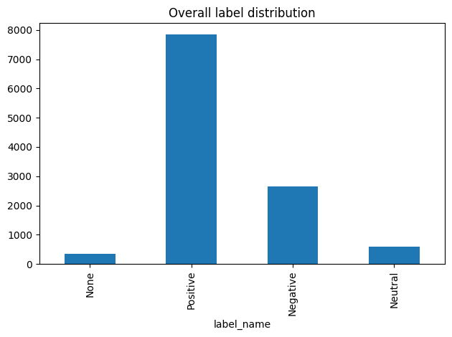
Figure 2. Overall Sentiment Label Distribution
Figure 3 presents a stacked bar chart by aspect, illustrating the proportion of the four sentiment labels (0/1/2/3) within each aspect. It can be observed that the None (0) label dominates across most aspects, indicating that not every review explicitly mentions all aspects. In contrast, the Positive, Negative, and Neutral labels exhibit varying distributions depending on the specific aspect.
Accordingly, Figure 3 highlights both the degree of aspect mention frequency and the distinct sentiment tendenciesassociated with each aspect. Moreover, this visualization provides a useful basis for identifying label imbalance at the aspect level and for considering appropriate mitigation strategies during the training and evaluation of the ABSA model.
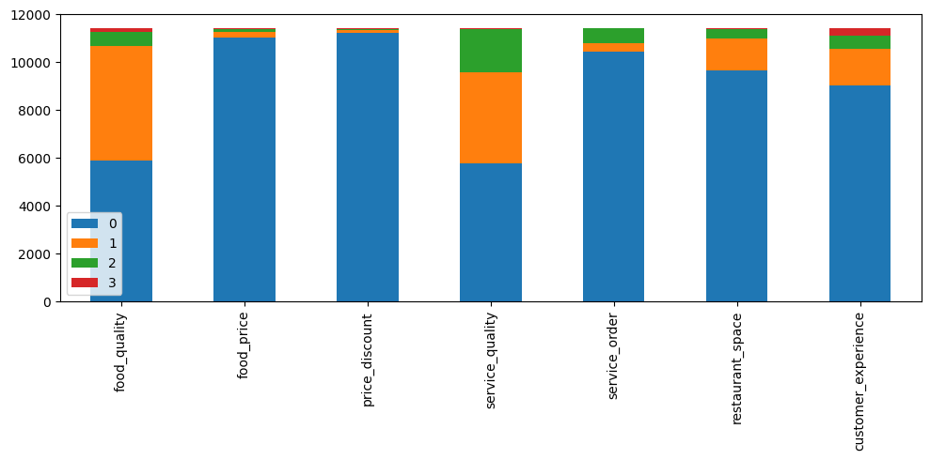
Figure 3. Sentiment Label Distribution by Aspect (Stacked Bar Chart)

4.5. Exploratory Data Analysis (EDA)
After completing the aspect identification process and manual sentiment annotation, an exploratory data analysis (EDA) is conducted on the fully labeled dataset. At this stage, each customer review has been associated with one or more predefined aspects and corresponding sentiment labels (None, Positive, Negative, or Neutral). Therefore, the purpose of this EDA is not to explore raw textual data, but rather to examine the structural characteristics, distribution patterns, and rating behavior of the sentiment-labeled dataset prior to model training.
This exploratory analysis serves three main objectives. First, it provides an overall understanding of customer rating patterns across KFC branches in Hanoi. Second, it examines how customer feedback is distributed across different aspects and sentiment categories. Third, it identifies potential imbalance issues and aspect-level characteristics that may influence the performance and interpretation of subsequent sentiment classification models.

4.5.1. Customer Rating Overview
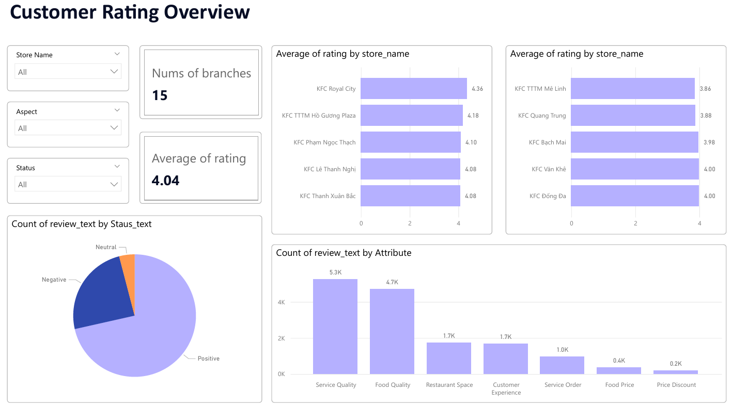
Figure 4. Customer Rating Overview and Aspect Distribution Across KFC Branches in Hanoi
Figure 4 presents an overview of customer ratings and feedback distribution across KFC branches in Hanoi. The dataset covers 15 KFC branches, providing sufficient coverage for branch-level and system-level analysis. The overall average customer rating is 4.04, indicating that customer perception toward KFC services is generally positive.
At the branch level, noticeable variation in average ratings can be observed. Some branches, such as KFC Royal City and KFC TTTM Hồ Gươm Plaza, achieve higher average ratings (above 4.2), while others record slightly lower scores. This variation suggests that customer experience is not uniform across locations and supports the need for a decision support system capable of analyzing performance differences at the branch level.
In terms of sentiment distribution, customer feedback is dominated by positive sentiment, which accounts for the majority of reviews. Negative sentiment represents a smaller but still meaningful proportion, while neutral sentiment appears infrequently. This pattern indicates that customers tend to express clear opinions when leaving reviews, rather than neutral or ambiguous feedback, which is consistent with typical behavior on online review platforms.
The analysis of aspect frequency further reveals that service quality and food quality are the most frequently discussed aspects, with approximately 5.3K and 4.7K mentions, respectively. These results suggest that customers primarily focus on staff behavior, service attitude, and food-related attributes when evaluating their dining experience. Other aspects, such as restaurant space and customer experience, appear with moderate frequency, while service order, food price, and price discount are mentioned less often.
Overall, the Customer Rating Overview highlights three key observations. First, customer sentiment toward KFC in Hanoi is generally positive. Second, customer attention is concentrated on core service and product-related aspects rather than pricing or promotions. Third, observable differences across branches and aspects justify the adoption of an aspect-based analytical approach, which enables more fine-grained insight than traditional overall rating analysis.

4.5.2. Aspect-level Rating Analysis
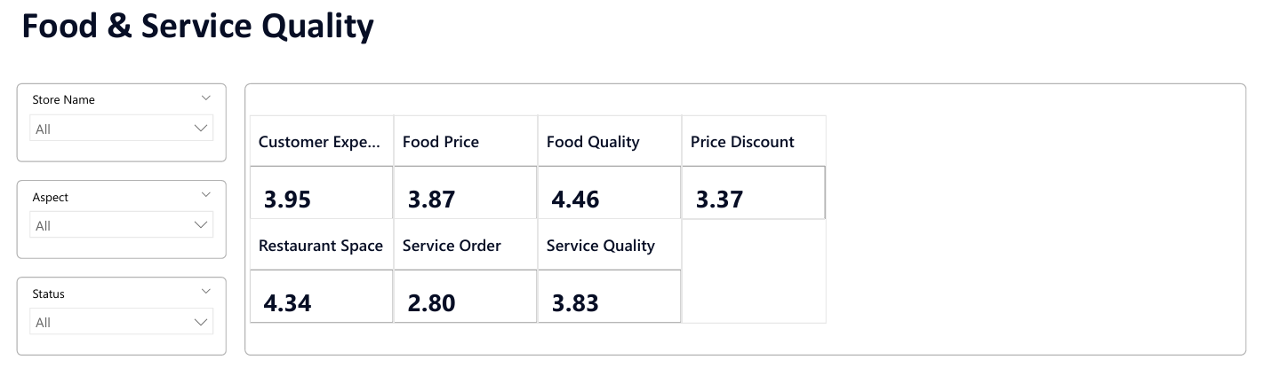
Figure 5. Average Aspect Ratings Across All KFC Branches
Figure 5 presents the average rating score for each service aspect, aggregated across all 15 KFC branches, based on customer ratings.
The results show that Food Quality receives the highest average rating (4.46), followed by Restaurant Space (4.34) and Customer Experience (3.95), indicating strong customer satisfaction with core product quality and dining environment.
In contrast, Service Order records the lowest average score (2.80), highlighting recurring issues related to waiting time, order accuracy, and service speed. Pricing-related aspects, including Food Price (3.87) and Price Discount (3.37), also receive comparatively lower ratings, suggesting customer sensitivity to perceived value and promotional policies.
Overall, this figure provides a high-level diagnostic view of strengths and weaknesses across service aspects, serving as an initial indication of which dimensions require deeper analysis in later stages.
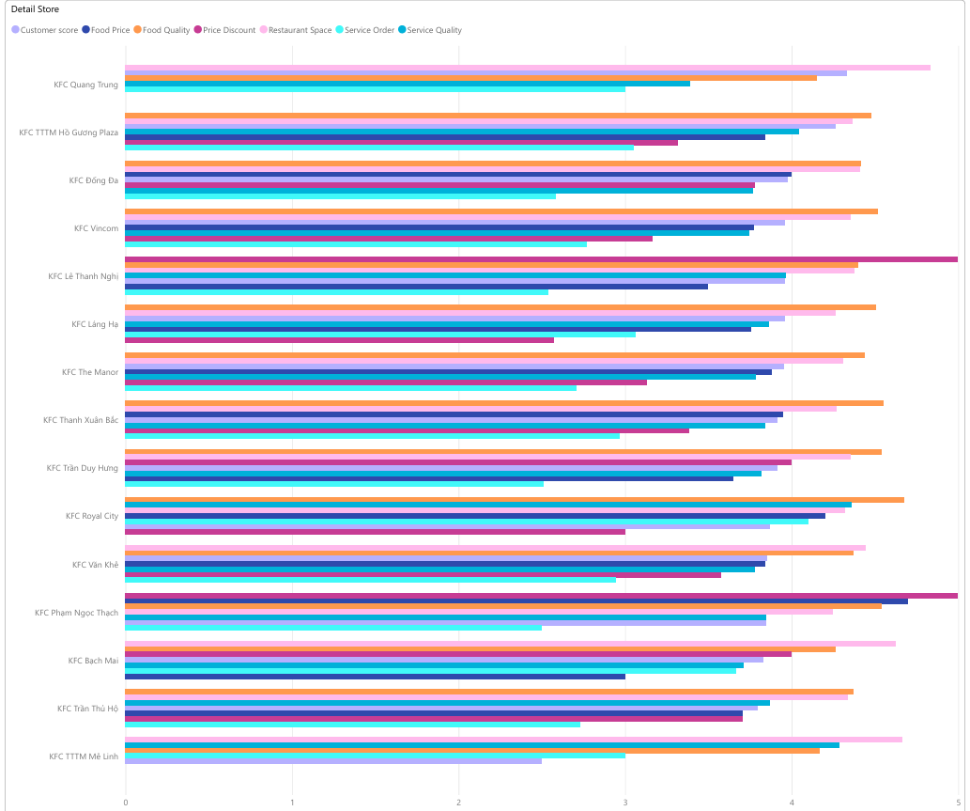
Figure 6. Aspect-level Rating Comparison Across KFC Branches
Figure 6 illustrates the distribution of average aspect ratings across individual KFC branches and enables a detailed comparison of branch-level performance. Each branch is evaluated across multiple service aspects, including food quality, service quality, service order, pricing, discounts, restaurant space, and overall customer experience.
The results indicate that food-related aspects show relatively consistent ratings across branches. This pattern reflects the standardized product quality maintained throughout the KFC system, where menu items and cooking procedures are largely uniform across locations. As a result, customer perceptions of food quality do not vary significantly between branches.
In contrast, service-related aspects, particularly Service Order and Service Quality, exhibit noticeable variation among branches. These differences suggest that local operational conditions, such as staff efficiency, service workflow organization, and peak-hour management, play a critical role in shaping customer evaluations. Branches with lower service-related ratings may face challenges related to waiting time, order accuracy, or staff responsiveness.
Pricing- and discount-related aspects also display uneven rating patterns across stores. This indicates differences in customer perceptions of value for money and the effectiveness or clarity of promotional programs at the branch level. Such variation highlights that customer satisfaction is influenced not only by product quality but also by localized service delivery and pricing experiences.
Overall, the findings from this figure emphasize the limitations of relying solely on overall ratings and underline the importance of aspect-level analysis. These observations provide strong motivation for applying Aspect-Based Sentiment Analysis in subsequent stages to identify specific operational strengths and weaknesses at individual KFC branches.

4.6. Proposed Modeling Approach
To address the Aspect-Based Sentiment Analysis (ABSA) task, this study adopts a modeling approach based on three traditional machine learning algorithms that have been extensively validated for text classification: Naive Bayes (NB), Logistic Regression (LR), and Support Vector Machine (SVM). The selection of these models serves not only to establish a robust performance baseline for comparison, but also to leverage their distinct architectural strengths in handling sparse and high-dimensional natural language features.
This study deliberately does not employ BERT or large language models (LLMs). Instead, it focuses on traditional machine learning models (SVM, LR, and NB) in order to strengthen foundational understanding of core AI and machine learning principles. As this work is conducted as a major course project, the primary objective is to develop analytical thinking and hands-on modeling skills from first principles. Traditional models enable clearer insight into feature engineering techniques, data representations, and the intrinsic characteristics of textual data, thereby supporting deeper conceptual learning.
From a practical perspective, the use of traditional machine learning models also supports resource and cost efficiency. Given that the dataset consists of customer reviews collected from Google Maps, these models provide an effective solution without requiring high-performance GPUs or extensive computational infrastructure. This choice ensures a fast, reproducible, and energy-efficient experimental workflow, which is well aligned with the scale and objectives of an academic report.
More importantly, within the context of business and enterprise management, model interpretability and transparency are critical considerations. Traditional models, particularly Logistic Regression, which offers explicit and interpretable keyword weights, provide inherent explainability. This stands in contrast to complex black box models whose decision mechanisms are difficult to interpret. Interpretable models are often preferable in high stakes or managerial decision making contexts, where trust and accountability are essential.
The first model evaluated in this study is Naive Bayes (NB). The application of Naive Bayes to text classification tasks has been well documented in early foundational studies on probabilistic classifiers [24]. The model is based on Bayes’ theorem and assumes conditional independence among features given the class label, an assumption that, despite its simplicity, has proven highly effective for high-dimensional text data.
$$P\left(C | D\right)∝P\left(C\right)\prod_{i=1}^{n}{P(t_{i}|C)}$$
where:
- $P\left(C | D\right)$ is the posterior probability, representing the probability that a document $D$ belongs to a sentiment class $C$. This is the quantity the model aims to predict.
- $P(C)$ is the prior probability, indicating the probability of the sentiment class $C$ before observing the document.
- $P\left(t_{i} | C\right)$ is the conditional probability, defined as the probability of term titi​ appearing in a document given sentiment class $C$.
- $D$ denotes the input document (i.e., a sentence or a review).
- $C$ represents the sentiment class (e.g., Positive, Negative, or Neutral).
- ti is the i-th term in document $D$, and $n$ denotes the total number of terms in $D$.
The application of this model to text classification tasks has been extensively described in early foundational studies on probabilistic event models [22].
In the context of Aspect Based Sentiment Analysis (ABSA), the simplicity and computational efficiency of Naive Bayes, particularly the Multinomial Naive Bayes variant that is well suited to word frequency based features, make it a strong and indispensable baseline model for Natural Language Processing tasks [23].
Next, Logistic Regression is employed as a discriminative classification model that estimates the probability of a document belonging to a specific sentiment class by applying a sigmoid function to a linear combination of input features [21]. The probability of the positive class, $P\left(Y=1 | x\right)$, is computed using the logistic function as follows [24]:
$$P\left(Y=1 | x\right)=\frac{1}{1+exp⁡(-\left(w^{T}x+b\right))}$$
where:
- $P\left(Y=1 | x\right)$ denotes the predicted probability, i.e., the probability that a document represented by feature vector $w$ belongs to the positive class ($Y=1$).
- $x$ is the input feature vector of the document (e.g., TF–IDF values of words).
- $w$ is the weight vector learned by the model, where each coefficient reflects the importance of the corresponding feature xi​ in the classification decision.
- $w^{T}x$ represents the dot product between the weight vector and the feature vector.
- $b$ is the bias (intercept) term, which shifts the decision boundary.
- $Y$ is the dependent variable (sentiment class), where $Y=1$ typically denotes the positive class
Logistic Regression (LR) is selected due to its transparency and interpretability. The model serves as an important bridge between simple probabilistic classifiers and more complex optimization-based models. By providing explicit feature weights, Logistic Regression enables direct interpretation of how individual textual features contribute to sentiment predictions, which is particularly valuable in both academic analysis and managerial decision-making contexts.
Finally, Support Vector Machine (SVM) is introduced as a more advanced classification approach. Fundamentally, the SVM learning process can be formulated as a constrained optimization problem [24]:
$$\min_{w,b,ξ}{\frac{1}{2}{||w||}^{2}+C\sum_{i=1}^{n}{ξ_{i}}}$$
$$subject to \\ \left\{\begin{aligned}y_{i}\left(w∙x_{i}+b\right)≥1-ξ_{i} \\ ξ_{i}≥0 for all i\end{aligned}\right.$$
where:
- $w$ is the parameter vector that defines the orientation of the separating hyperplane, with the objective of maximizing the margin between classes.
- $b$ is the bias (offset) term, which adjusts the position of the hyperplane within the feature space.
- $C$ is the regularization parameter, controlling the trade-off between model complexity and classification error.
- $ξ_{i}$​ represents the slack variable, measuring the degree to which the ii-th data point violates the margin constraints in the soft-margin SVM setting.
- $x_{i}$​ is the feature vector of the i-th data point.
- y$y_{i}$ denotes the sentiment class label of $x_{i}$​, typically taking values +1 or −1.
Support Vector Machine (SVM) is considered a strategic choice due to its effectiveness in handling high-dimensional and sparse feature spaces, a characteristic that has been widely demonstrated as optimal for text classification tasks involving large vocabularies [21]. Moreover, the ability to employ kernel techniques (e.g., the Radial Basis Function (RBF) kernel) allows SVM to capture complex non-linear relationships between words and sentiment expressions, enabling the model to achieve high accuracy in challenging text classification problems, including ABSA.
The concurrent selection of Naive Bayes, Logistic Regression, and Support Vector Machine represents a deliberate strategy to establish a comprehensive evaluation framework for the ABSA task, encompassing three distinct levels of model complexity and learning paradigms. Comparing these architectures enables the identification of the minimum model complexity required to achieve optimal performance.
Specifically, Naive Bayes is adopted to establish a probabilistic baseline. Its simplicity and computational efficiency provide an initial reference point against which performance improvements introduced by more sophisticated models can be assessed. The use of a baseline model is a common and recommended practice in text classification research [23].
Logistic Regression represents a linear, weight-learning model and is prioritized for its transparency and interpretability. This model allows researchers to directly interpret learned feature weights, offering valuable insights into the role of individual lexical features in driving aspect-level sentiment decisions. Such interpretability is particularly important for understanding sentiment mechanisms and for applications in managerial and strategic analysis.
Finally, Support Vector Machine is employed to explore the upper performance bound of traditional machine learning approaches, a strategy widely supported in comparative sentiment classification studies [23]. With its capacity to model non-linear decision boundaries in high-dimensional spaces, SVM is expected to achieve the highest classification accuracy among the selected models, thereby establishing a performance ceiling for comparison.
Overall, the selection of these three models enables a holistic evaluation of the trade offs among interpretability, computational cost, and classification performance. By comparing the outcomes of these models, which represent an independent probabilistic classifier (Naive Bayes), an interpretable linear model (Logistic Regression), and a margin based optimization model (Support Vector Machine) [23], this study aims to identify the traditional machine learning architecture that offers the most balanced and effective solution for the ABSA task. These models are applied after lexical and aspect level features are extracted and encoded, and their results are systematically compared to draw final conclusions regarding the optimal modeling approach.

V. Implementation and Evaluation

5.1. System Implementation
The proposed system in this study is implemented as a Decision Support System (DSS) based on Aspect-Based Sentiment Analysis (ABSA), with the aim of supporting KFC managers in monitoring, analyzing, and improving customer experience through data-driven insights. The system focuses on transforming large volumes of unstructured customer reviews into structured and interpretable information that can be directly used in managerial decision-making.
From an overall perspective, the system is developed as an end-to-end analytical pipeline. Customer reviews collected from Google Maps across 15 KFC branches in Hanoi serve as the input data. These reviews are first processed through a standardized text preprocessing pipeline in order to clean and normalize the raw textual content. The processed text is then analyzed using aspect-based sentiment classification models, which identify the sentiment polarity associated with each predefined service aspect, including food quality, service quality, restaurant space, pricing, and overall customer experience.
The system is implemented using Python as the core development environment, which integrates data preprocessing, sentiment classification, and result generation into a unified analytical pipeline. After the training phase, the sentiment classification models are stored and reused during system deployment, allowing the system to apply a consistent analytical procedure to newly collected reviews without the need for retraining models from scratch. The complete workflow, from text preprocessing to sentiment prediction, is integrated into a unified system architecture, ensuring stability, efficiency, and scalability.
The analytical results are delivered through an interactive decision-support dashboard. The dashboard provides a visual representation of KFC branch locations together with sentiment summaries by aspect, sentiment distribution charts, dominant keywords, and representative customer reviews. Users can flexibly filter the results by branch, aspect, sentiment category, and time period. This interactive design enables managers to quickly detect operational issues, track sentiment trends over time, and understand the underlying reasons behind customer feedback. By combining quantitative sentiment indicators with qualitative textual evidence, the system effectively functions as a practical DSS that bridges advanced sentiment analysis techniques and real-world service management requirements.

5.2. Experimental Setup
The evaluation is conducted following an aspect-wise classification strategy, in which each aspect is treated as an independent multi-class sentiment classification task. For each aspect, records with missing sentiment labels are removed, and sentiment labels are standardized into four categories: 0 (None – aspect not mentioned), 1 (Positive), 2 (Negative), and 3 (Neutral). Aspects with an insufficient number of samples or containing only a single sentiment class are excluded from the experiments to ensure model stability and meaningful evaluation.
The input to the models consists of preprocessed review text, following the cleaning, normalization, and translation steps described in earlier sections. Each review is represented using a TF–IDF vectorization scheme, incorporating both unigrams and bigrams, while terms appearing fewer than two times across the entire corpus are removed. This representation enables the models to better capture sentiment-indicative phrases (e.g., “too expensive,” “slow service,” “spacious environment”), which are particularly important for aspect-level sentiment analysis.
For each aspect, the dataset is split into training and testing sets using an 80/20 ratio. The split is performed randomly but with a fixed seed to ensure reproducibility. When label distributions allow, class proportions are preserved across the training and testing sets to mitigate bias arising from class imbalance.
Using the same TF–IDF feature representation, three classification models are trained and compared:
- Linear Support Vector Machine (Linear SVM)
- Logistic Regression (LR)
- Multinomial Naive Bayes (MNB)
Each model is implemented as a unified processing pipeline consisting of TF–IDF transformation followed by classification. This ensures that performance differences arise solely from the classifiers themselves rather than variations in preprocessing. The primary evaluation metric is classification accuracy on the test set for each aspect. For each aspect, the model achieving the highest accuracy is identified as the best-performing model and retained for system deployment.

5.3. Evaluation Results
Table 6 presents the test-set accuracy of the three classifiers across seven aspects: food_quality, food_price, price_discount, service_quality, service_order, restaurant_space, and customer_experience. Each row corresponds to an individual aspect, while the first three columns report the accuracy of Support Vector Machine (SVM), Logistic Regression (LR), and Naive Bayes (NB). The final two columns indicate the best-performing model for each aspect and its corresponding accuracy value.
As observed in Table 6, all models achieve relatively strong performance, with accuracy values ranging from 0.79 to 0.98. Overall, SVM and Logistic Regression consistently outperform Naive Bayes across most aspects, suggesting that discriminative linear models are better suited to TF–IDF representations of short and noisy customer reviews.
Table 6. Accuracy Comparison of 3 Models Across Aspects
aspect | svm_acc | lr_acc | nb_acc | best_model | best_acc
food_quality | 0.91 | 0.90 | 0.83 | svm | 0.91
food_price | 0.98 | 0.98 | 0.97 | svm | 0.98
price_discount | 0.98 | 0.98 | 0.98 | lr | 0.98
service_quality | 0.91 | 0.90 | 0.87 | svm | 0.91
service_order | 0.92 | 0.92 | 0.92 | lr | 0.92
restaurant_space | 0.92 | 0.92 | 0.86 | lr | 0.92
customer_experience | 0.85 | 0.86 | 0.79 | lr | 0.86
When analyzed at the aspect level, price-related aspects are the easiest to classify. For both food_price and price_discount, all three models achieve accuracy values of approximately 0.97–0.98, with the best-performing model for each aspect reaching 0.98. This indicates that sentiments related to pricing and promotions are typically expressed using clear and strongly polarized language, making them easier for classifiers to identify.
For food_quality, Support Vector Machine (SVM) achieves the highest accuracy (0.91), slightly outperforming Logistic Regression (0.90) and significantly exceeding Naive Bayes (0.83). These results suggest that SVM’s margin-based linear separation is particularly effective at capturing descriptive phrases related to food attributes such as taste, temperature, and texture.
Service-related aspects, including service_quality and service_order, achieve best-model accuracies of approximately 0.91 and 0.92, respectively. Compared to price-related aspects, these results are slightly lower, reflecting the fact that evaluations of staff attitude or service speed often involve contextual and implicit expressions, which are inherently more difficult to classify.
For restaurant_space, Logistic Regression yields the highest accuracy (0.92), while Naive Bayes achieves only 0.86. Reviews concerning cleanliness, comfort, and atmosphere typically combine objective descriptions with subjective impressions, a pattern well suited to a linear probabilistic model that optimizes log-odds.
Finally, customer_experience is the most challenging aspect to classify. The best performing model, Logistic Regression, attains an accuracy of 0.86, whereas Naive Bayes records the lowest performance at 0.79. This outcome is expected because customer experience represents an overall evaluation that often simultaneously references multiple dimensions such as food, service, restaurant space, pricing, and even comparisons with competing brands. As a result, sentiment signals associated with this aspect become more diffuse and difficult to isolate.
Factors Affecting Classification Performance
One of the primary factors influencing classification performance lies in the compatibility between the learning algorithms and the data representation method. The use of TF–IDF vectors combining both unigrams and bigrams results in a high-dimensional and highly sparse feature space. In such settings, linear discriminative models such as Support Vector Machine (SVM) and Logistic Regression demonstrate clear advantages, as they are capable of identifying optimal separating boundaries between sentiment classes even when reviews are short and contain noisy or informal language.
In contrast, Naive Bayes relies on the assumption of conditional independence among words, an assumption that rarely holds in natural language. For example, word pairs such as “service” and “slow” exhibit strong semantic dependence. This rigid assumption limits the ability of Naive Bayes to capture meaningful word interactions, preventing it from achieving performance levels comparable to those of Support Vector Machine and Logistic Regression.
Examining individual models more closely, Support Vector Machine performs particularly well on aspects characterized by strong qualitative descriptions, such as food quality and service related aspects. Its margin optimization mechanism enables the model to effectively capture distinctive phrases describing product states, including taste, temperature, and crispiness. In contrast, Logistic Regression shows an advantage for aspects that involve a mixture of objective observations and subjective impressions, such as restaurant space. By optimizing log odds probabilities, Logistic Regression handles evaluative expressions related to comfort or ambiance, which are more abstract than purely physical attributes, in a smoother and more stable manner.
In addition to model feature compatibility, the linguistic characteristics of each aspect play a crucial role in determining classification difficulty. Price and discount related aspects achieve near perfect accuracy, reaching values of up to 0.98, because customers tend to use highly explicit, strongly polarized, and stable vocabulary such as “expensive,” “cheap,” “worth it,” or “promotion.” These consistent lexical cues allow all three models to identify sentiment with relative ease.
Conversely, customer_experience represents the most challenging aspect, exhibiting the lowest accuracy range from 0.79 to 0.86. This difficulty arises from its broad and integrative nature. Within a single sentence, customers often simultaneously reference multiple dimensions such as food, service, restaurant space, pricing, and even comparisons with competing brands. As a result, aspect specific sentiment signals become diluted, making it difficult for models to assign accurate sentiment weights to the overall customer experience aspect.
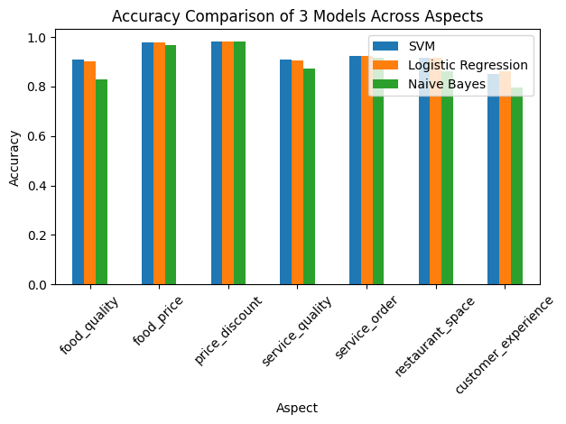
Figure 7. Accuracy Comparison of 3 Models Across Aspects

5.4. Application
The ABSA results obtained from customer reviews across 15 KFC branches in Hanoi reveal an overall sentiment landscape structured around seven key aspects. Positive sentiment dominates core dimensions such as food_quality, service_quality, restaurant_space, and customer_experience, indicating generally favorable customer perceptions in these areas. In contrast, aspects related to service_order, food_price, and price_discount exhibit a higher concentration of negative sentiment clusters, suggesting recurring operational and value related concerns that warrant managerial attention.
The practical contribution of this study is most clearly demonstrated through the interactive ABSA based decision support dashboard developed as a system prototype. The main interface, shown in Figure 8, visualizes the geographic distribution of KFC branches in Hanoi alongside a detailed feedback panel, allowing users to select a specific branch and immediately explore its associated customer reviews. To support this spatial visualization, three additional attributes, namely location, latitude, and longitude, are incorporated into the dataset for each branch based on information retrieved from Google Maps. These geographic attributes enable accurate branch level mapping and enhance the interpretability of sentiment patterns across locations.
The system provides a flexible set of filters based on store location, aspect, sentiment label (Positive, Negative, Neutral, or None), and time range, enabling managers to analyze customer sentiment under highly specific conditions. As filter parameters are adjusted, the Sentiment Summary by Aspect and the Sentiment Chart by Aspect components are updated in real time. This functionality allows decision makers to quickly grasp sentiment structures in concrete scenarios, such as identifying patterns of negative service quality feedback at a specific branch over a selected time period. Such targeted insights are difficult to obtain using traditional aggregate sentiment analysis approaches.
A key strength of the proposed system lies in its ability to link sentiment outcomes with concrete textual evidence. At the detailed analysis level, the dashboard simultaneously presents two complementary information blocks, including a Top Keywords table and a list of Sample Reviews corresponding to the selected filter combination. For example, when selecting the service_order aspect with negative sentiment, the system highlights dominant keywords related to issues such as waiting time, slow service, incorrect orders, and delivery problems, together with representative customer review excerpts. This enables managers not only to identify where problems occur, but also to understand what customers are explicitly complaining about.
With this structure, the proposed application effectively functions as a decision support dashboard. Managers can monitor sentiment trends across branches, aspects, and time periods, isolate operational hotspots related to service order or service quality, and prioritize corrective actions such as process optimization, staff training, or adjustments to pricing and promotional strategies. Importantly, these decisions are grounded in quantitative evidence directly derived from customer feedback, thereby bridging the gap between data analytics and practical service management.
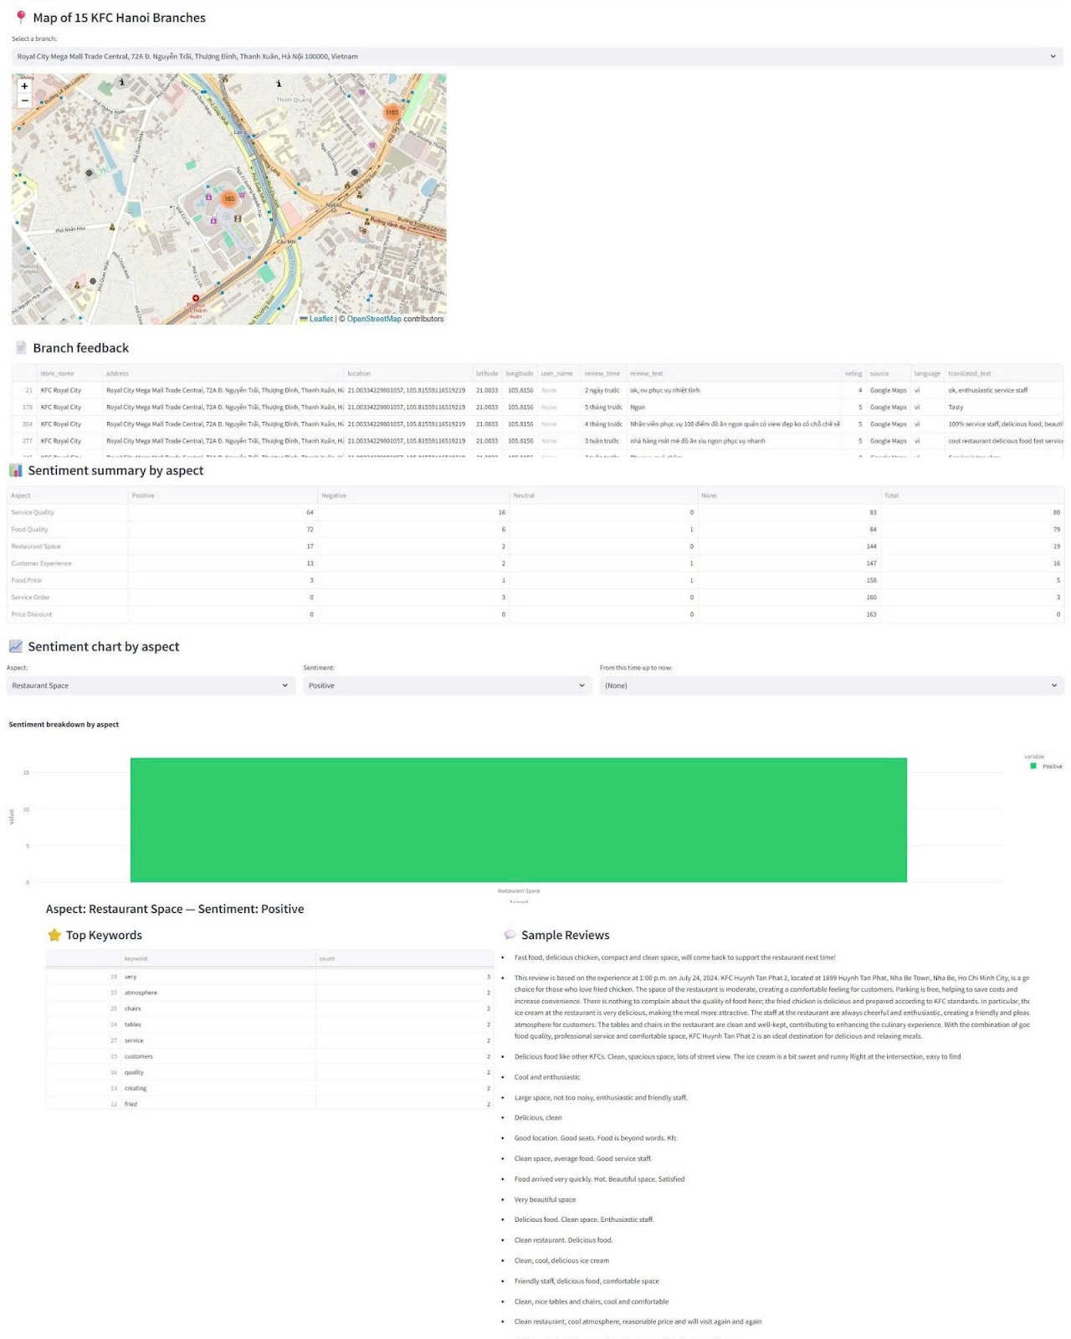
Figure 8. Interactive Branch Map and Review Dashboard for 15 KFC Stores in Hanoi

5.5. Limitations and Future Work

5.5.1. Limitations
This study has several limitations that should be considered when interpreting the results.
First, the original customer reviews were written in Vietnamese and subsequently translated into English using Google Translate for analysis. Machine translation may fail to preserve subtle semantic nuances and cultural contexts embedded in Vietnamese expressions of sentiment. For example, sarcastic remarks or socially polite compliments may not be accurately conveyed after translation. However, this limitation is not expected to severely affect the findings of this study, as the analysis relies on TF–IDF, a relatively simple feature representation that focuses on word frequency rather than deep semantic understanding. As long as key sentiment-bearing terms such as “good,” “bad,” “slow,” or “expensive”are preserved during translation, the models are still able to perform effectively.
Second, sentiment annotation at the aspect level was conducted manually by members of the research team. Although a shared annotation guideline was established and group discussions were held to resolve ambiguous cases, the study did not formally measure inter-annotator agreement using metrics such as Cohen’s Kappa. Consequently, variations in interpretation among annotators may still exist, particularly for reviews containing vague, implicit, or mixed sentiments.
Third, the dataset exhibits a noticeable class imbalance across sentiment labels. The “None” label (indicating that an aspect is not mentioned) appears most frequently, while positive and negative sentiments are unevenly distributed across aspects such as food quality, service quality, restaurant space, and pricing. Some aspects contain relatively few samples in minority classes, which may affect model performance, as machine learning algorithms tend to learn more effectively from majority classes while producing less reliable predictions for underrepresented ones.
Finally, accuracy is used as the primary evaluation metric in this study. For a multi-class classification problem with imbalanced data, relying solely on accuracy can be misleading. A model may achieve high accuracy simply by correctly predicting the majority class while failing to capture important minority classes. To obtain a more comprehensive assessment, future studies should incorporate additional evaluation metrics such as precision, recall, and F1-score for each class, as well as carefully examine the confusion matrix to better understand model strengths and weaknesses across different sentiment categories.

5.5.2. Future Work
This study can be extended in several directions in future research. First, the development of multilingual ABSA systems would help preserve semantic nuances and cultural context in the original language, rather than relying on translation into English as in the current approach. In addition, modern language models such as BERT or large language models could significantly enhance the ability to capture deep contextual meaning and handle subtle sentiment expressions, including sarcasm or implicit opinions, which are not well represented by TF IDF features.
To provide a more objective assessment of the proposed approach, future studies should conduct comparative evaluations against other ABSA systems using the same dataset or established benchmark datasets. Such comparisons would help clearly identify the strengths, limitations, and specific contributions of the proposed methodology.
From a data perspective, expanding the dataset by collecting reviews from multiple platforms such as Facebook, Foody, Shopee Food, and over longer time periods would enable the model to learn more diverse sentiment patterns. A richer and more diverse dataset would also help mitigate class imbalance issues and improve the model’s generalization capability when applied to different domains or business contexts.
Finally, integrating real time sentiment monitoring and analysis could move the system from a research oriented setting toward practical deployment. A real time ABSA system would allow businesses to continuously track customer feedback, detect service or product issues at an early stage, and respond promptly to improve overall customer experience.

VI. Conclusion
This study demonstrates that Aspect Based Sentiment Analysis (ABSA) is a powerful and practical approach for extracting fine grained and actionable insights from customer feedback. The research successfully applies ABSA to analyze 11,436 customer reviews collected from 15 KFC branches in Hanoi. By focusing on seven specific aspects of the service experience, including food quality, pricing, promotions, service quality, restaurant space, service process, and overall customer experience, the proposed ABSA system provides a level of insight that goes well beyond the capabilities of traditional overall sentiment analysis.
The experimental results show that traditional machine learning models, particularly Support Vector Machine and Logistic Regression, achieve high classification performance, with accuracy reaching up to 0.98. These results confirm the feasibility and effectiveness of the proposed approach when applied to real world and noisy customer review data, validating the suitability of ABSA for practical business analytics.
The practical value of this research is further demonstrated through the development of an interactive dashboard, which transforms complex analytical outputs into an intuitive and manager friendly decision support tool. The dashboard enables real time monitoring of sentiment trends, precise identification of operational hotspots such as prolonged waiting times at specific branches, and a clearer understanding of the root causes behind customer opinions through representative keywords and sample review excerpts. This provides a robust quantitative foundation for strategic decision making related to service improvement, staff training, and marketing policy adjustments.
Despite its potential, the deployment of ABSA systems also faces several challenges, including accurate aspect extraction, handling mixed or implicit sentiments, and ensuring objectivity and consistency in model predictions. Nevertheless, with the rapid advancement of natural language processing and machine learning, these limitations are expected to be progressively addressed. Future ABSA systems are likely to evolve toward multimodal integration, multilingual analysis, and real time large scale deployment, further enhancing their analytical power and business relevance.
In conclusion, this study not only confirms the value of ABSA in transforming customer voices into meaningful and actionable insights but also provides a deployable analytical framework and toolset tailored to the food and beverage industry. By adopting ABSA, businesses such as KFC can improve customer satisfaction, optimize operational performance, and strengthen their competitive positioning, ultimately delivering more personalized and market responsive service experiences. The future of ABSA in this domain is highly promising, and organizations that adopt such data driven technologies early will be better equipped to thrive in an increasingly competitive and insight driven marketplace.

REFERENCES
[1] Vietnam, K. (n.d.). Về KFC. Retrieved from KFC Vietnam Tuyển Dụng. https://tuyendung.kfcvietnam.com.vn/ve-kfc
[2] ScienceDirect. (n.d.). Aspect-based sentiment analysis. Retrieved November 19, 2024, from https://www.sciencedirect.com/topics/computer-science/aspect-based-sentiment-analysis
[3] Pontiki, M., Galanis, D., Papageorgiou, H., Androutsopoulos, I., Manandhar, S., Al-Smadi, M., Al-Ayyoub, M., Zhao, Y., Qin, B., De Clercq, O., Hoste, V., Apidianaki, M., Tannier, X., Loukachevitch, N., Kotelnikov, E., Bel, N., Jiménez-Zafra, S. M., & Eryiğit, G. (2016). SemEval-2016 Task 5: Aspect Based Sentiment Analysis. Proceedings of the 10th International Workshop on Semantic Evaluation, 19-30. https://aclanthology.org/S16-1002/
[4] Al-Smadi, M., Al-Ayyoub, M., & Jararweh, Y. (2022). Aspect-Based Sentiment Analysis of Arabic Restaurants Customers' Reviews Using a Hybrid Approach. International Journal of Communication Systems, 35(16), e5501.https://www.researchgate.net/publication/366142583_Aspect-Based_Sentiment_Analysis_of_Arabic_Restaurants_Customers'_Reviews_Using_a_Hybrid_Approac
[5] Khotimah, P. A., & Wahyuni, S. (2021). Aspect-based sentiment analysis on online customer reviews: A case study of Tripadvisor. Journal of Hospitality and Tourism Technology, 14(2), 102-120.https://www.emerald.com/jhtt/article-abstract/14/2/102/432202/Aspect-based-sentiment-analysis-on-online-customer?redirectedFrom=fulltext
[6] Li, W., & Chen, X. (2023). Aspect-Based Sentiment Analysis of Customer Reviews in E-Commerce. Journal of Data Science and Analytics, 15(4), 245-263.https://www.researchgate.net/publication/387019147_Aspect-Based_Sentiment_Analysis_of_Customer_Reviews_in_E-Commerce
[7] Carrasco, P., & Dias, S. (2024). Enhancing Restaurant Management through Aspect-Based Sentiment Analysis and NLP Techniques. Procedia Computer Science, 237, 129-137.https://www.sciencedirect.com/science/article/pii/S1877050924011049
[8] Amalia, P. R., & Winarko, E. (2021). Aspect-Based Sentiment Analysis on Indonesian Restaurant Review Using a Combination of Convolutional Neural Network and Contextualized Word Embedding. IJCCS (Indonesian Journal of Computing and Cybernetics Systems), 15(3), 285-294. https://journal.ugm.ac.id/ijccs/article/view/67306
[9] Rahman, A., Khan, M. A., Bishnu, K. K., Rozario, U., Ishraq, A., Mridha, M. F., & Aung, Z. (2025). Multilingual sentiment analysis in restaurant reviews using aspect-focused learning. Scientific Reports, 15(1), 28371. https://www.nature.com/articles/s41598-025-12464-y
[10] Jeong, D., Kim, D., Yan, J., & Li, J. (2024). Effect of Aspect-Level Emotion Expression of Online Restaurant Reviews on Perceived Helpfulness: An Aspect-Based Sentiment Analysis Perspective. Journal of Theoretical and Applied Electronic Commerce Research, 19(3), 754-772. https://journals.sagepub.com/doi/full/10.1177/21582440251337195
[11] George, S., & Srividhya, V. (2023). Implicit aspect based sentiment analysis for restaurant review using LDA topic modeling and ensemble approach. International Journal of Advanced Technology and Engineering Exploration, 10(102). https://www.proquest.com/openview/6af98b15a8a741458842611f859242ac/1?pq-origsite=gscholar&cbl=2037694
[12] Li, H., Yu, B. X. B., Li, G., & Gao, H. (2023). Restaurant survival prediction using customer-generated content: An aspect-based sentiment analysis of online reviews. Tourism Management, 97, 104707. https://www.sciencedirect.com/science/article/abs/pii/S0261517722002205
[13] Andhika, L. D., Pratiwi, I. D., & Wibowo, R. P. (2023). Analisis Sentimen Konsumen KFC Berdasarkan Pendekatan Naïve Bayes dan AdaBoost Berbasis Data Twitter. Jurnal Inovasi Informatika, 8(1), 22-30. https://jurnal.bsi.ac.id/index.php/jinsan/article/view/2219
[14] Nguyen, C., Nguyen, D., & Do, T. (2019). The Determinants of Customer Satisfaction in Fast Food Industry: The Case Study of KFC Vietnam. Humanities and Social Science Research, 2(2), 17-25. https://papers.ssrn.com/sol3/papers.cfm?abstract_id=3906107
[15] Service Quality: Parasuraman, A., Zeithaml, V. A., & Berry, L. L. (1988). A conceptual model of service quality and its implications for future research. Journal of Marketing, 52(2), 35–48.
https://www.researchgate.net/publication/225083670_A_Conceptual_Model_of_Service_Quality_and_its_Implication_for_Future_Research_SERVQUAL
[16] Customer Experience: Pine, B. J., II, & Gilmore, J. H. (1999). The experience economy: Work is theatre & every business a stage. Harvard Business School Press.
https://www.labster8.net/wp-content/uploads/2014/03/Pine-Gilmore.pdf
[17] Food Quality: Ryu, K., Han, H., & Jang, S. S. (2010). The effect of environmental perceptions on behavioral intentions through cognitive and affective responses in a restaurant. Journal of Hospitality & Tourism Research, 34(2), 173–198.
https://www.researchgate.net/publication/240282861_The_Effect_of_Environmental_Perceptions_on_Behavioral_Intentions_Through_Emotions_The_Case_of_Upscale_Restaurants
[18] Restaurant Space: Bitner, M. J. (1992). Servicescapes: The impact of physical surroundings on customers and employees. Journal of Marketing, 56(2), 57–71.
https://www.ida.liu.se/~steho87/und/htdd01/9208310667.pdf
[19] Service Order: Maister, D. (1985). The psychology of waiting lines. In J. A. Czepiel, M. R. Solomon, & C. F. Surprenant (Eds.), The Service encounter: Managing employee/customer interaction in service businesses (pp. 113–123). Lexington Books.
https://www.researchgate.net/publication/200085847_The_Psychology_of_waiting_lines
[20] Price_Discount: Mela, C. F., Gupta, S., & Lehmann, D. R. (1997). The long-term impact of promotion and advertising on consumer brand choice. Journal of Marketing Research, 34(2), 248–261.
https://www.researchgate.net/publication/240480451_The_Long_-_Term_Impact_of_Promotion_and_Advertising_on_Consumer_Brand_Choice
[21] Joachims, T. (1998). Text Categorization with Support Vector Machines: Learning with Many Relevant Features. Proceedings of the 10th European Conference on Machine Learning (ECML), 137–142.https://www.cs.cornell.edu/people/tj/publications/joachims_98a.pdf
[22] McCallum, A., & Nigam, K. (1998). A Comparison of Event Models for Naive Bayes Text Classification. Proceedings of the AAAI-98 Workshop on Learning for Text Categorization, WS-98-05, 41–48.https://cdn.aaai.org/Workshops/1998/WS-98-05/WS98-05-007.pdf
[23] Wang, S., & Manning, C. D. (2012). Baselines and bigrams: Simple, good sentiment and topic classification. Proceedings of the 50th Annual Meeting of the Association for Computational Linguistics (Volume 2: Short Papers), 90–94.https://aclanthology.org/P12-2018.pdf
[24] Bishop, C. M. (2006). Pattern Recognition and Machine Learning. Springer.
https://www.microsoft.com/en-us/research/wp-content/uploads/2006/01/Bishop-Pattern-Recognition-and-Machine-Learning-2006.pdf
[25] Blei, D. M., Ng, A. Y., & Jordan, M. I. (2003). Latent Dirichlet Allocation. Journal of Machine Learning Research, 3, 993–1022. https://www.jmlr.org/papers/volume3/blei03a/blei03a.pdf
[26] Newman, D., Lau, J. H., Grieser, K., & Baldwin, T. (2010). Automatic evaluation of topic coherence. Human Language Technologies: The 2010 Annual Conference of the NAACL. https://aclanthology.org/N10-1012.pdf
[27] Röder, M., Both, A., & Hinneburg, A. (2015). Exploring the space of topic coherence measures. Proceedings of the Eighth ACM International Conference on Web Search and Data Mining. https://dl.acm.org/doi/abs/10.1145/2684822.2685324
[28] Blei, D. M., Ng, A. Y., & Jordan, M. I. (2003). Latent Dirichlet Allocation. Journal of Machine Learning Research, 3, 993–1022. https://www.jmlr.org/papers/volume3/blei03a/blei03a.pdf

